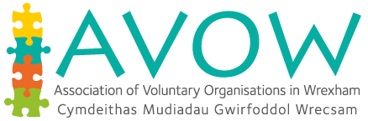



Does your organisation need funding for a youth work project that will make a difference to the community and support young people?
Organisations working with young people aged 11-25 can now apply for £200 to £500 from the Youth Service Strategy Revenue Grant 2018/2019.

What could you do with
£200 – £500?


For more information please contact:
Tricia Jones – ctricia.jones@wrexham.gov.uk 01978 317961
Caroline Bennett – caroline.bennett@wrexham.gov.uk 01978 317961
The panel will be meeting to consider application on set dates throughout the year*, if you would like to have your application considered please return complete forms by:
1st Closing date - Friday 29th June
2nd Closing date - Friday 28th September
3rd Closing date - Friday 23rd November
*Please allow 3 weeks from the closing date for notification of outcome and money to be processed

